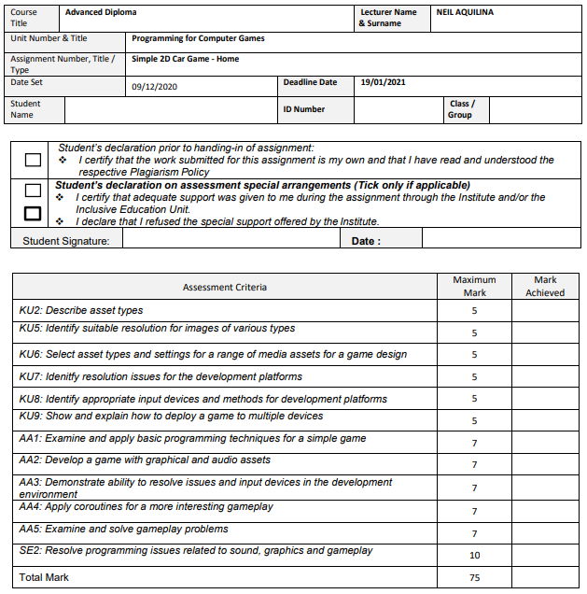

18/01/2021

4.2B

116303L

Josue` Camilleri

**Task 3:**

|  |  |
| --- | --- |
| Test Case 1 |  |
| Line Error | if (health <= 0 && valueScore < 100) ; |
| Error Explanation | In the “Player” script there is an extra semicolon. |
| Error Correction | The extra semicolon at the end of the line was removed in order to complete the if statement. |
| Error Correction ScreenShot |  |

|  |  |
| --- | --- |
| Test Case 2 |  |
| Line Error | -- a problem within the Inspector. -- |
| Error Explanation | The playerDeathSound needs to be added to the Player prefab, and into the “Player (Script)” component from the Inspector. |
| Error Correction | playerDeathSound was added to the Player prefab from the Inspector. |
| Error Correction ScreenShot |  |

|  |  |
| --- | --- |
| Test Case 3 |  |
| Line Error | --Need to add a scene-- |
| Error Explanation | The “scene” could not be loaded because it has not been added to the build settings. |
| Error Correction | The “scene” scene was accidentally unticked from the Build Settings. |
| Error Correction ScreenShot |  |

|  |  |
| --- | --- |
| Test Case 4 |  |
| Line Error | FindObjectOfType<GameSession>().ResetGame(); |
| Error Explanation | The game cannot find the GameSession in the Scene |
| Error Correction | GameSession prefab was moved in the Hierarchy |
| Error Correction ScreenShot |  |

|  |  |
| --- | --- |
| Test Case 5 |  |
| Line Error |  |
| Error Explanation |  |
| Error Correction |  |
| Error Correction ScreenShot |  |

|  |  |
| --- | --- |
| Test Case 6 |  |
| Line Error |  |
| Error Explanation |  |
| Error Correction |  |
| Error Correction ScreenShot |  |

|  |  |
| --- | --- |
| Test Case 7 |  |
| Line Error |  |
| Error Explanation |  |
| Error Correction |  |
| Error Correction ScreenShot |  |

|  |  |
| --- | --- |
| Test Case 8 |  |
| Line Error |  |
| Error Explanation |  |
| Error Correction |  |
| Error Correction ScreenShot |  |

|  |  |
| --- | --- |
| Test Case 9 |  |
| Line Error |  |
| Error Explanation |  |
| Error Correction |  |
| Error Correction ScreenShot |  |

|  |  |
| --- | --- |
| Test Case 10 |  |
| Line Error |  |
| Error Explanation |  |
| Error Correction |  |
| Error Correction ScreenShot |  |

|  |  |
| --- | --- |
| Test Case 11 |  |
| Line Error |  |
| Error Explanation |  |
| Error Correction |  |
| Error Correction ScreenShot |  |

|  |  |
| --- | --- |
| Test Case 12 |  |
| Line Error |  |
| Error Explanation |  |
| Error Correction |  |
| Error Correction ScreenShot |  |

|  |  |
| --- | --- |
| Test Case 13 |  |
| Line Error |  |
| Error Explanation |  |
| Error Correction |  |
| Error Correction ScreenShot |  |

|  |  |
| --- | --- |
| Test Case 14 |  |
| Line Error |  |
| Error Explanation |  |
| Error Correction |  |
| Error Correction ScreenShot |  |